# My Contact

nikammansi412@gmail.com

9309896793 https://www.linkedin.com/in /mansi-nikam-b51755245/ https://github.com/Mansi1024



# TECHNICAL SKILLS

Languages: Java, Python,

HTML, CSS, JavaScript, SQL

Operating System: Windows,

Linux (Ubuntu)

Domains: Front-end WebDevelopment, UI-UX ,digitalmarketing. Tools : Figma ,replit , Canva

**Acedemics:**

S.E. (Information technology) in June 2023, Savitribai Phule Pune University 7.68 SGPA F.E. (Information technology) in June 2022, Savitribai Phule Pune University 8.39 SGPA

H.S.C. in June 2021,

Maharashtra State Board

Education with 85%

S.S.C. in June 2019,

Maharashtra State Board

Education with 91.60%

Aspiring IT engineering student passionate about front-end web development and UI/UX design. Proficient in HTML, CSS, and JavaScript, I am dedicated to creating visually stunning and user-centric digital solutions. Eager to apply my skills and collaborate on exciting projects, I am actively seeking intern opportunities to gain real-world experience and contribute to innovative teams. With a strong drive for learning and an eye for design aesthetics, I am committed to crafting seamless and engaging user experiences.

**Mansi Nikam**

**About Me**

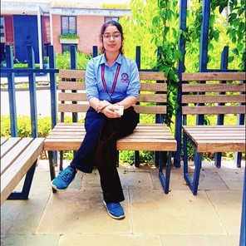

**Web Devlopment intern**

# Projects

**PBL :**

CHATBOT for college website

Created a chatbot feature for college website to get related info of university

**DBMS :**

Restaurant Management system

Various use-cases of a Restaurant Management System were implemented using Java and MySQL database

**WT:**

Created a travel agency website (Trip-O-Deal) using HTML & CSS Created Amazon clone website

# Certifications

Virtual Internship at CODSOFT ( Web Development –

Ongoing)

User experience design fundamentals - by Udemy

Fundametals of digital marketing - by Google garage

Google Cloud Career Practitioner Program - GDSC KBTCOE

# Co-curricular

First prize in Mandala competition at cultural event at

KBTCOE

Volunteered in Technical and Cultural Events of KBTCOE

Participation in Poster making Competition by ITSA